
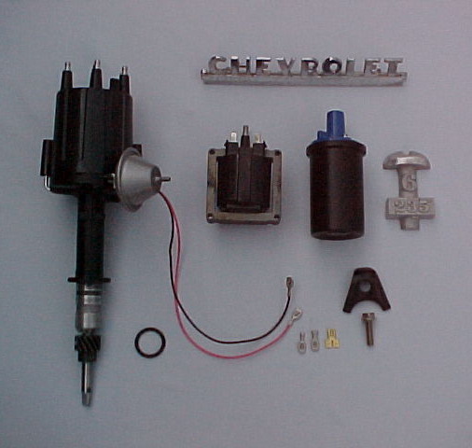
Langdon's Stovebolt Engine Parts Co.
47950 Robin Street - Utica, Michigan 48317
Fax/Phone (586)-739-9601
Website: www.stoveboltengineco.com
Email: theboss@stoveboltengineco.com
- Full electronic- no maintenance required
- High Energy output
- Allows usage of .060" gap spark plugs
- Uses all standard components easily available at any auto parts store
- General Motors system reliability
- Has full centrifugal and vacuum advance systems
- Clears all Chevy and GMC standard and finned aluminum side covers
- Same diameter as original distributor (3 1/2") (slightly taller)
- 12 volt
Mini HEI
*Note price of $160.00 includes rectangular coil. Round coil shown above is available for $10.00 extra.

Fits all Chevy 216, 235, 261 and GMC *engines
*Some versions require steel distributor gears before installation
NOTE: MOPAR MINI IS SIMILAR TO THIS CHEVY UNIT

